**INDIAN TOURISM**

**Mini Project Documentation**

This mini project is one of the modules created for Indian Tourism using ABAP on SAP. This module is for New User Registration and for Booking Of the Package by the User.

**Assumptions:**

**Under User Part:**

1. User wants to go on a trip to a particular place. So he visits this website to book a package.
2. User Login ,User details update and Booking details modification and update are done in a separate module.

**TABLE OF CONTENTS**

1. Tables Used
2. New User Registration Screen
3. View Packages and Fare
4. Choosing Of Package and for Other Facilities to choose
5. Payment Screen
6. Confirmed Payment Screen
7. Generation Of Invoice

**Tables Used:**

Booking Table:

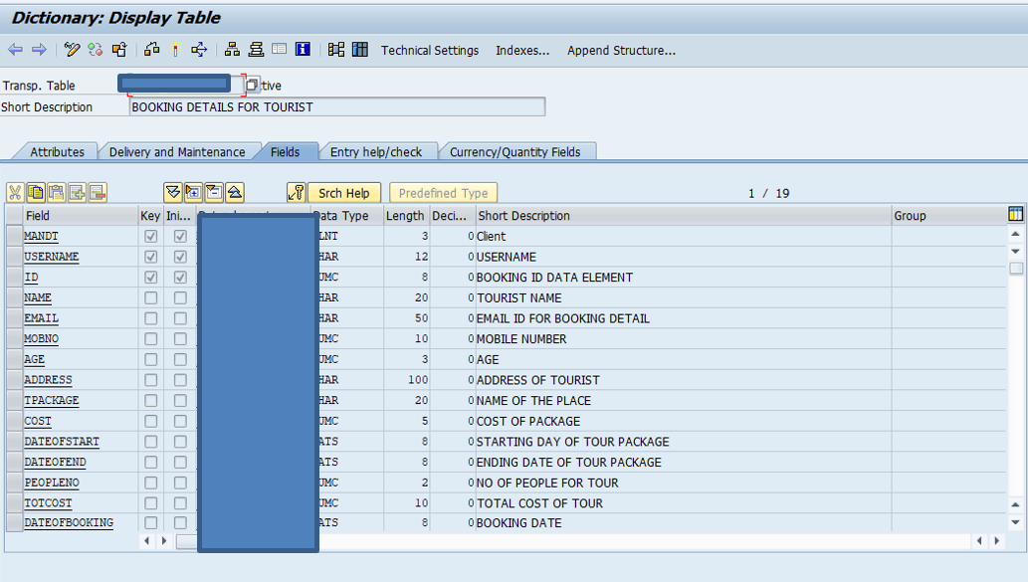

Package Table :

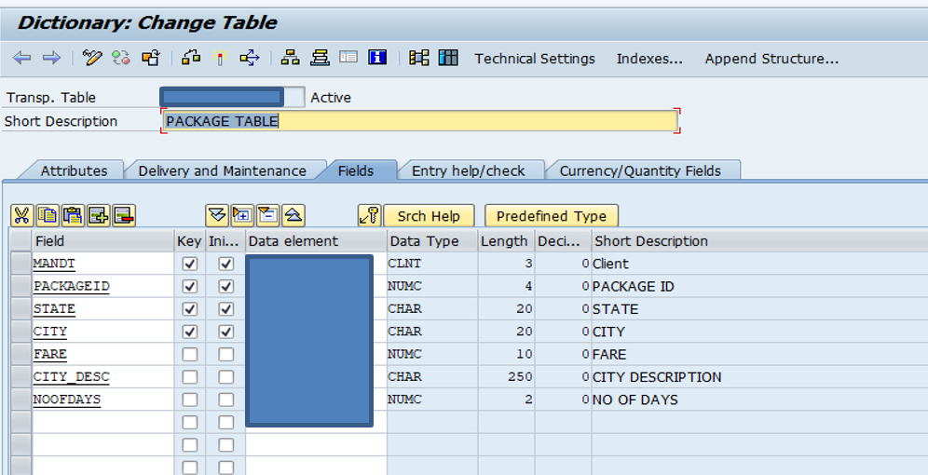

Cost Table : For other useful fields

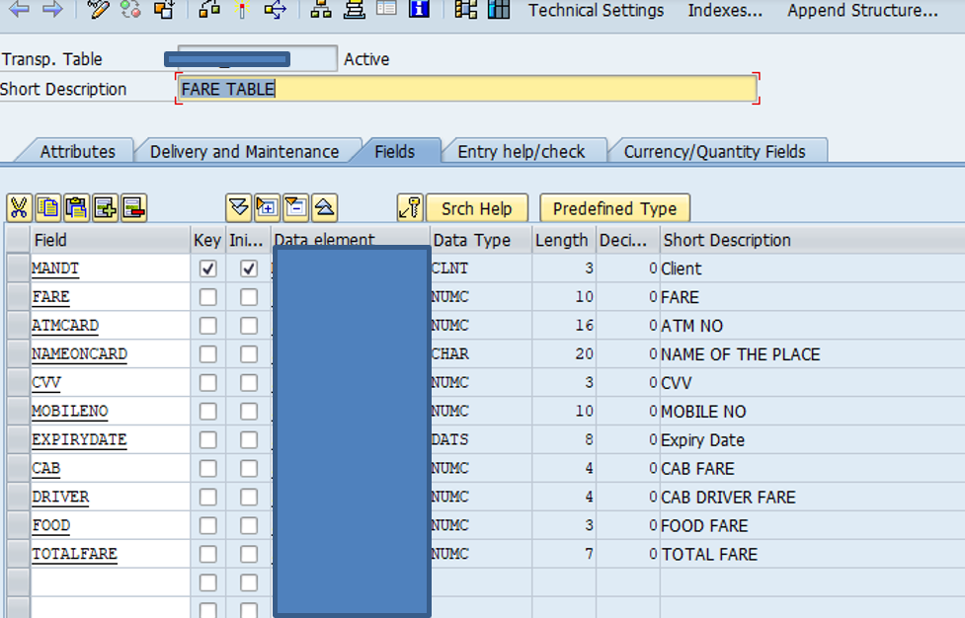

1. Flow Logic:

**Welcome Page**

**NEW USER REGISTRATION**

1. FLOW LOGIC

**Double click on package**

**Other Facilities**

**View Package Fare**

**INVOICE**

**Confirmation**

**Payment Screen**

**FUNCTIONALITIES:**

**1.Welcome Page**

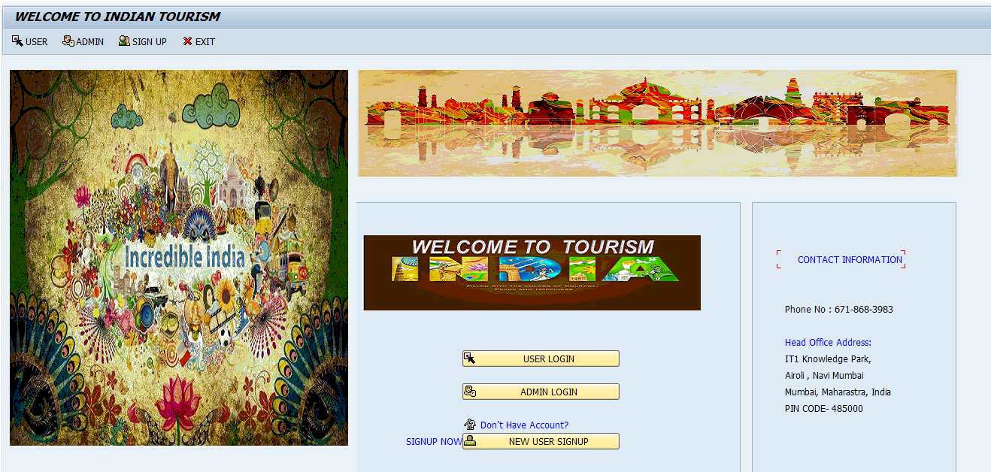

**Press Signup for a new user registration**

**1a.For the Signup Screen**

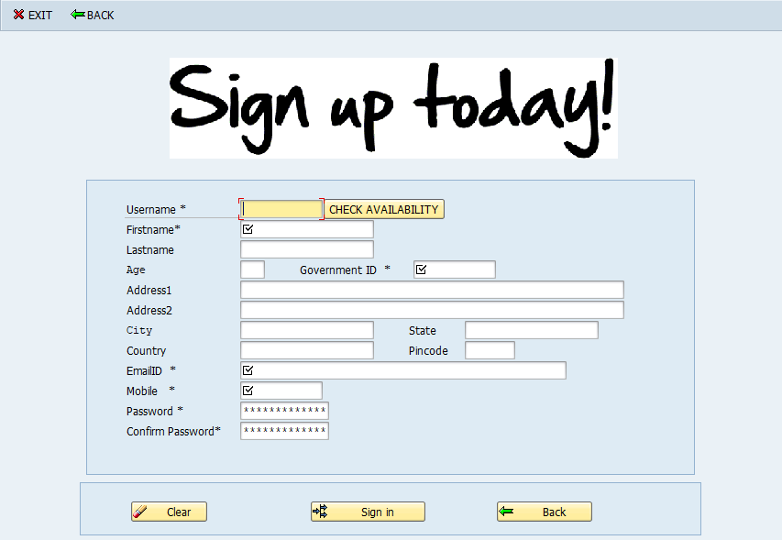

**Check Availability:** Used to check whether the username is available or already used.

All the required fields are filled. Some fields are mandatory and must be filled to sign-in.

Password and confirm password must be matched to enter to the next page.

**Validations:** Done for

1. Government ID
2. Email ID
3. Mobile Number
4. Password.

**Main Page :**

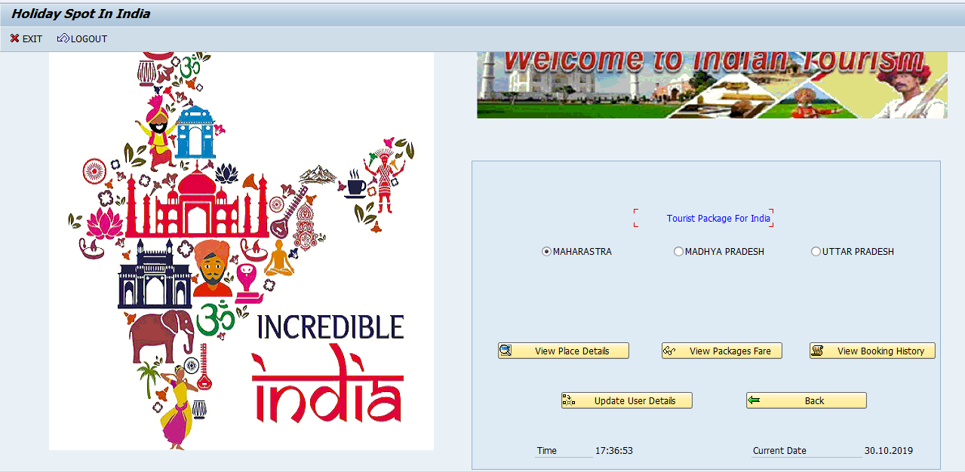

Press on View Package Fare to book and package and move further

**2.VIEW PACKAGE FARE AND BOOKING OF A PACKAGE**

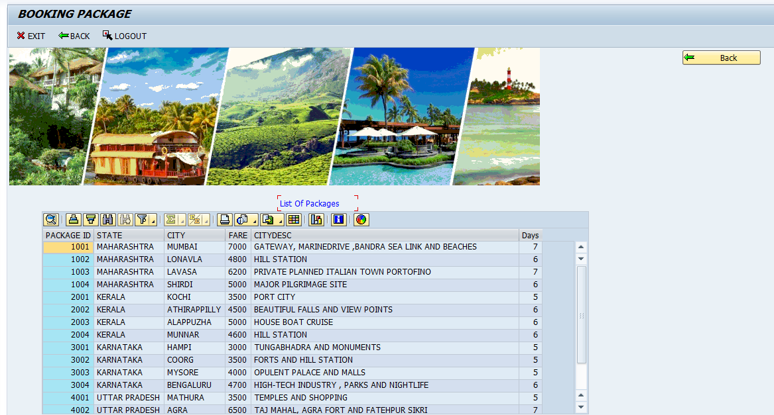

Selection of a Package is done here

The user need to double click on the place he need to go and then the details of the package like package ID , State,City,Fare and City Description will be displayed.

Functionality used:

OOALV Double click Method is used here.

Now the selected Package is

1. Package ID - 2002

2. State – Kerala

3.City – Athirappilly

4.Fare – 4500

5.City Description – Beautiful Falls and View Points

6.No Of Days - 6

**3.Choosing Of Other Facilities**

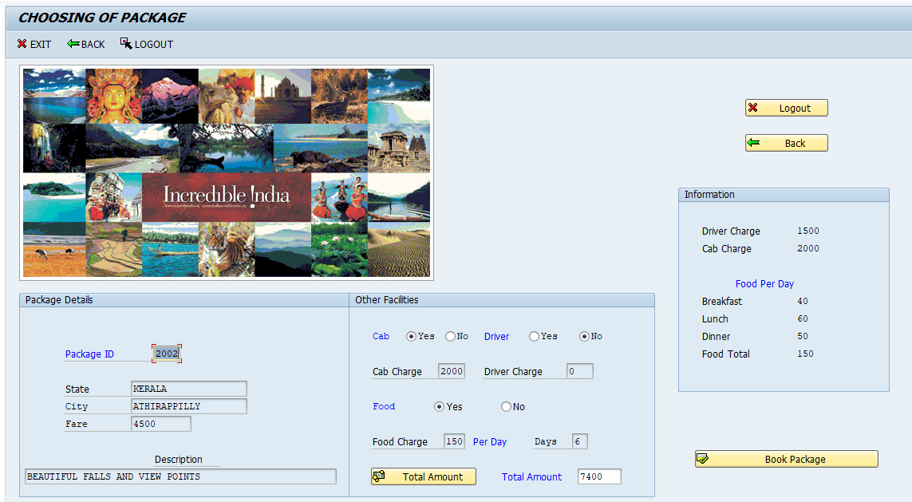

Other Facilities for the User to choose:

If a Cab is needed --- If Yes, Charge is 2000

If a driver is needed --- If Yes, Charge is 1500

If food is required for the whole trip --- Per Day * 150

The Total Amount is Package Fare+ Cab Fare+ Driver Fare + 150*No.of Days.

**4.Payment Screen**

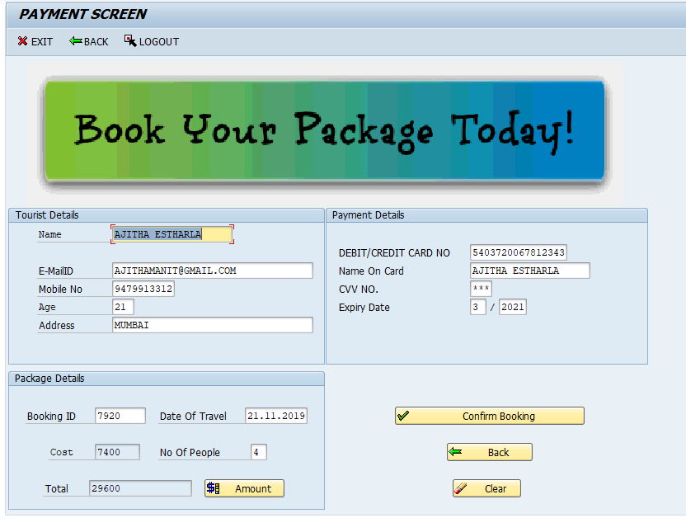

**Filling Of the Tourist Details is done here**

**\*BOOKING ID is generated in this screen\***

1. Under Tourist Details : Basic Information of Tourist is given here.This will be printed on the invoice of the package booked.
2. Under Package Details : Amount = No Of People * Cost Of whole package
3. Under Payment Details : Details of Card is given for payment

**Validations are done for :**

Debit Card / Credit Card : Must be 16 digits.

Cvv No. : Must be 3 digits.

Expiry Date : Month < 12 and Year > present year.

**For Confirmation of Booking**: Say Yes and then Payment is done

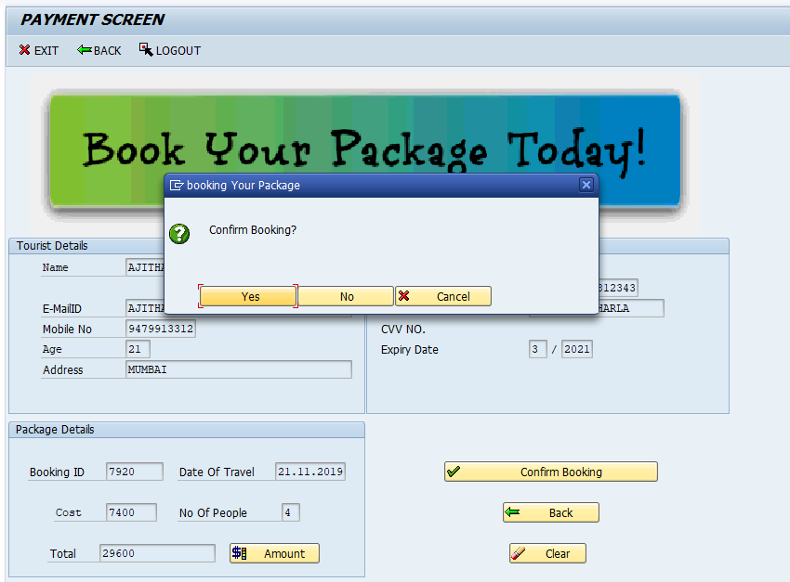

**Confirmation Of Payment and Details of Tourist is displayed here:**

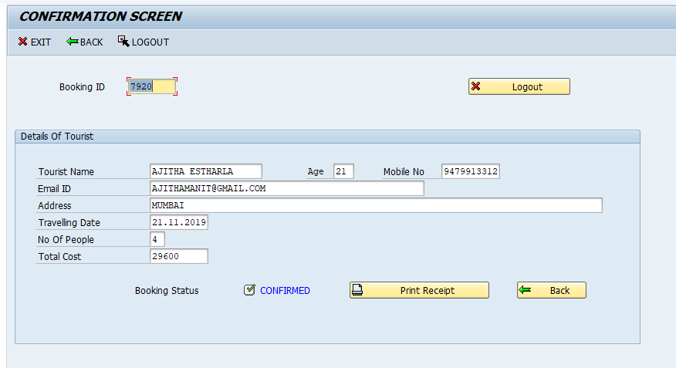

**Under Print Receipt : Adobe Form : Invoice is generated.**

